LAN -- ALL ZONE

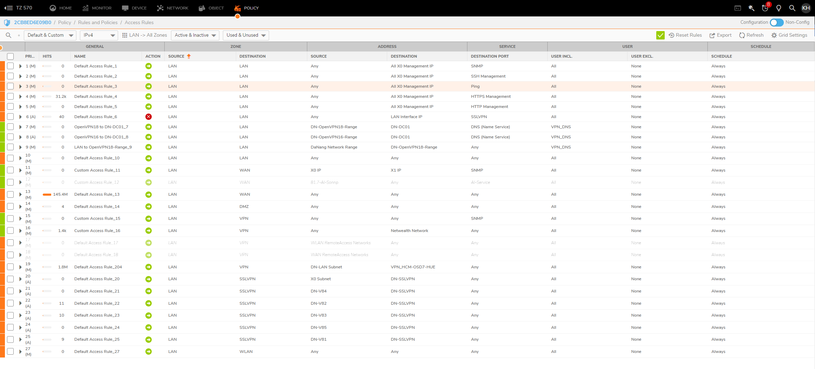

WAN – ALL ZONE

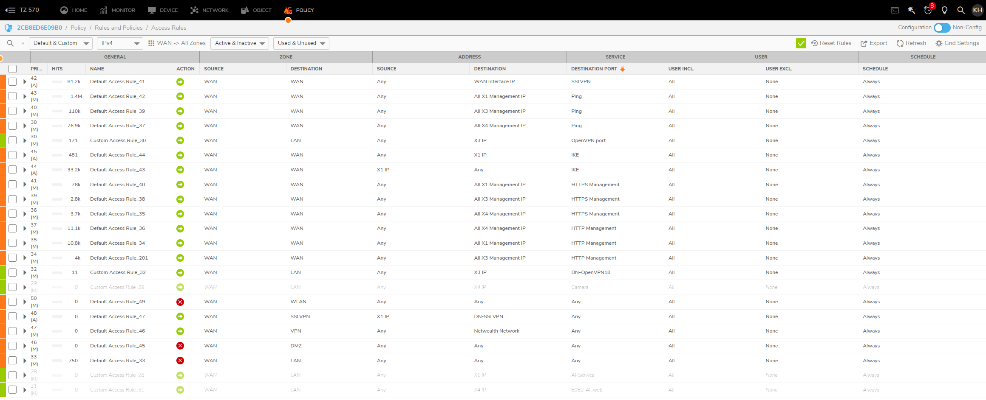

DMZ – ALL ZONE

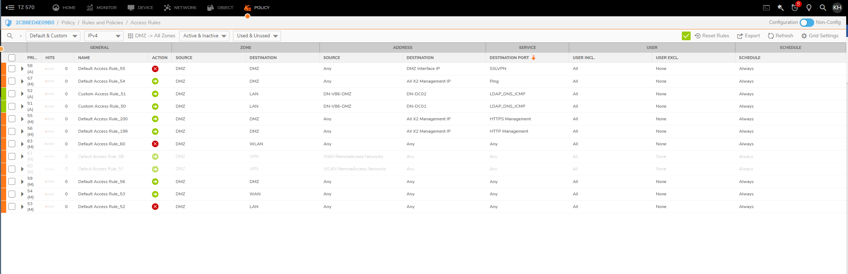

SSLVPN – ALL ZONE

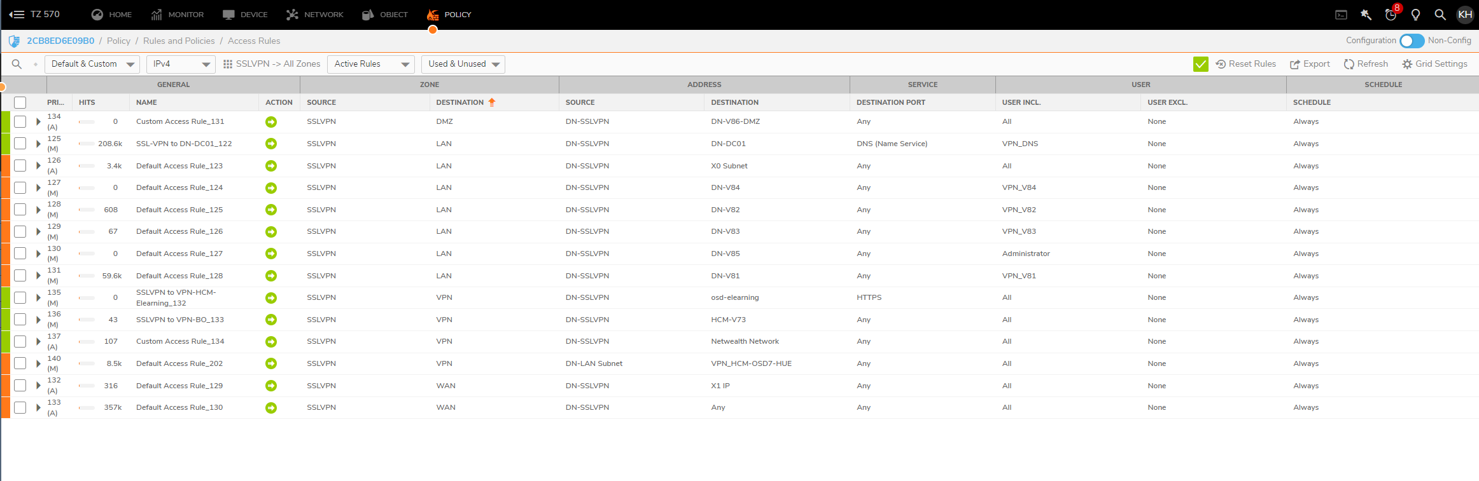

VPN – DMZ

VPN – LAN

VPN – WAN

VPN –VPN

VPN – SSLVPN

VPN – WLAN

WAN – ALL ZONE

NAT – RULES

NAT One To One

**Access Rules**

NAT Policy

